NIIT UNIVERSITY DISCUSSION PORTAL

TESTING

BLACKBOX TESTING

Members:

Shronit Bhargava, Utkarsh Srivastava, Yatham praveen, Saurabh Kaushal, Siddhartha kille.

As the black box testing suggests we reviewed our website from a Lehman user’s perspective i.e without involving the codes.

**Login Page**:

**Positive Scenario**

**Inputs**: Valid Username and Password

**Desired Outputs**: Redirected to Appropriate Pages based on the type of user



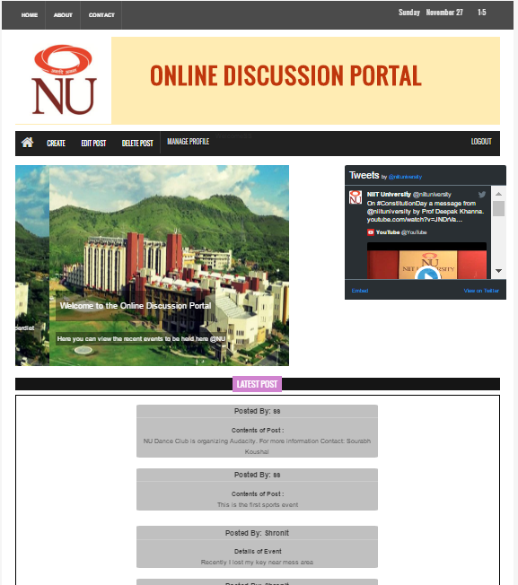

**Actual Output**: The website redirects to the correct pages

**Negative Scenario**: Invalid Credentials

Input: Wrong Username and Password

Desired Output:Redirected to the login page again and give message invalid input



Actual output: redirected To Login Page again

TEST CASE STATE: Succesful

**Home page**

Desired output:Show all the current posts



Actual Output: Posts are being shown

**Create Posts (Create event, lost and found post)**

Input: Enter data and send for approval

Desired Output: request is send to the admin for approval

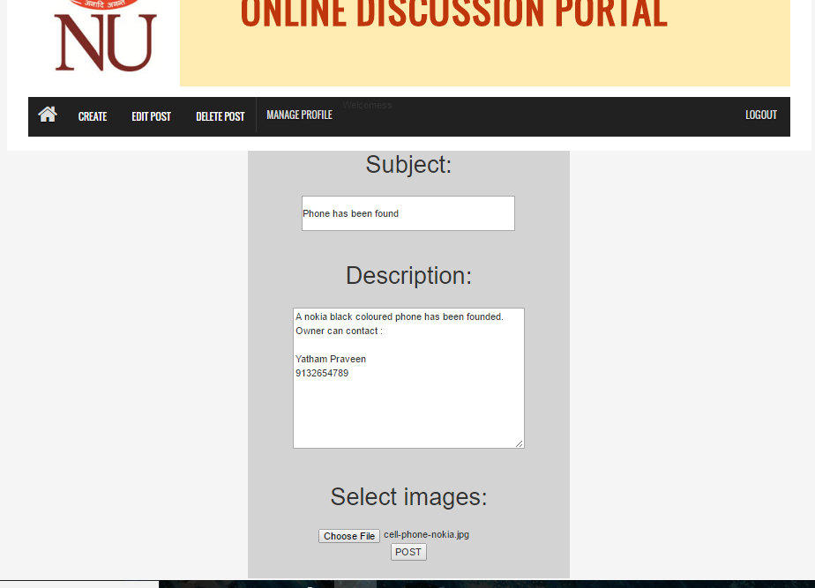

Actual Output: Request was send for approval

**Negative Scenario:**

Input:Clicks create post button without entering the details

Desired Output:Post should not be created and a message should appear

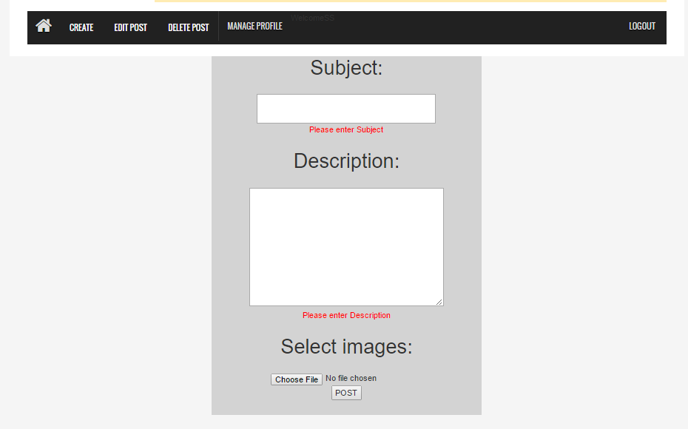

Actual Output:Post is not send for approval and a message appears

**Edit Posts**

Input: Select the post to edit and enter the new data

Desired Output: The request is send to admin for editing the data and after the approval the previous data is replaced by the new data

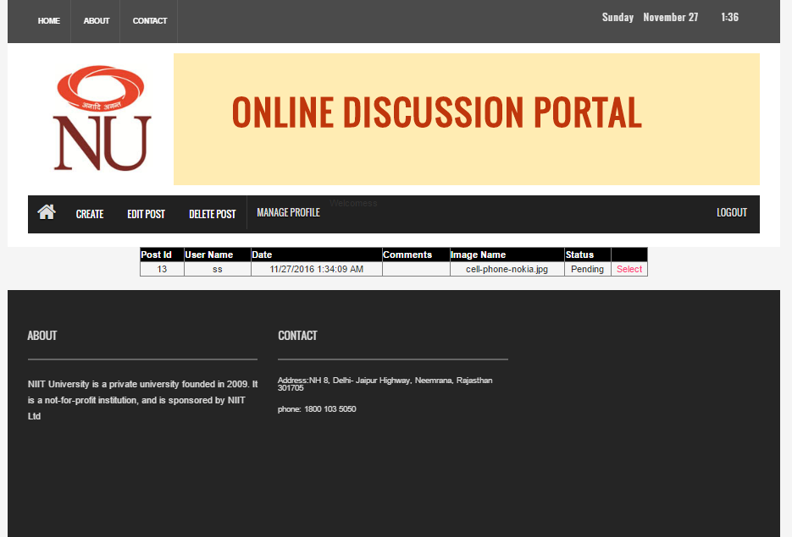

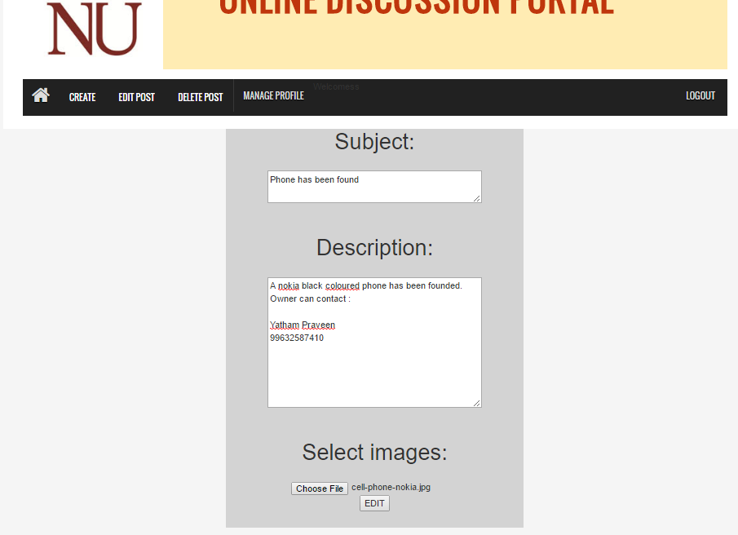

Actual Output: The previous data was replaced by the current data after approval

Delete Post(Delete the lost,found or event post created by the respective user also by admin)

Input:Select the required post to delete and then that post should get deleted from the database

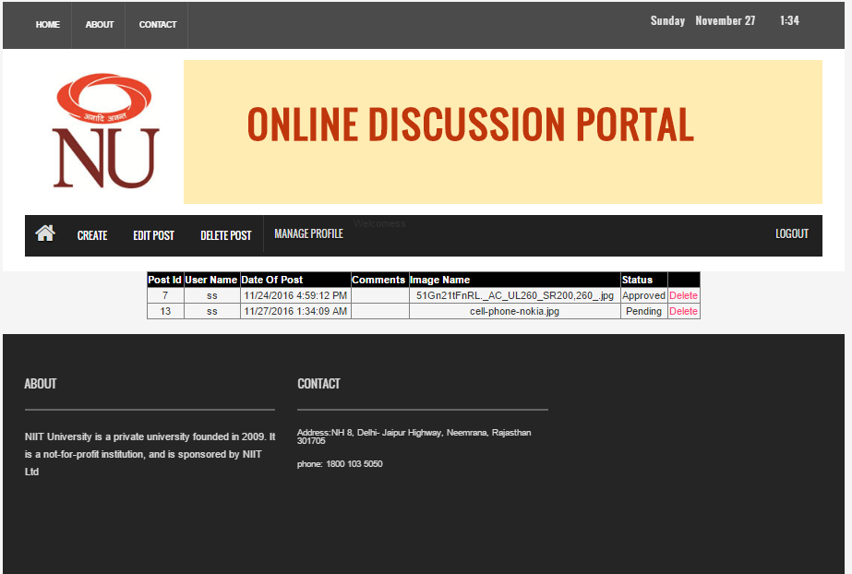

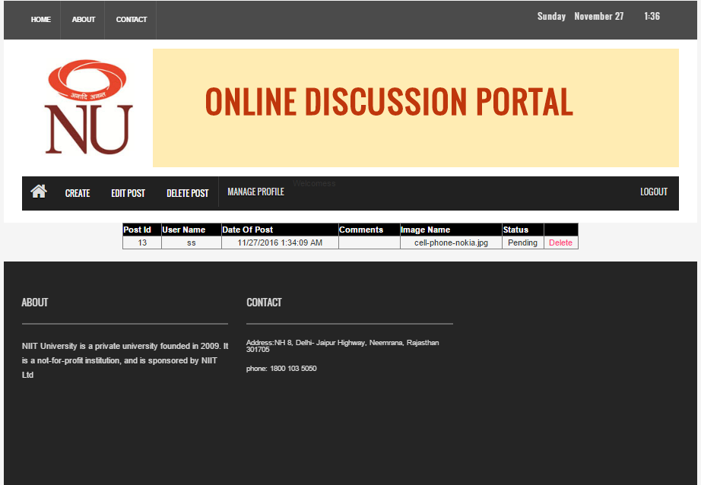

Desired Output:The selected post should get deleted from the database

Actual Output:the selected post should get deleted

**Manage Profile:**

Input: Enter the changes the user wants to make In the data

Desired Output: The new changes should be updated in the database successfully

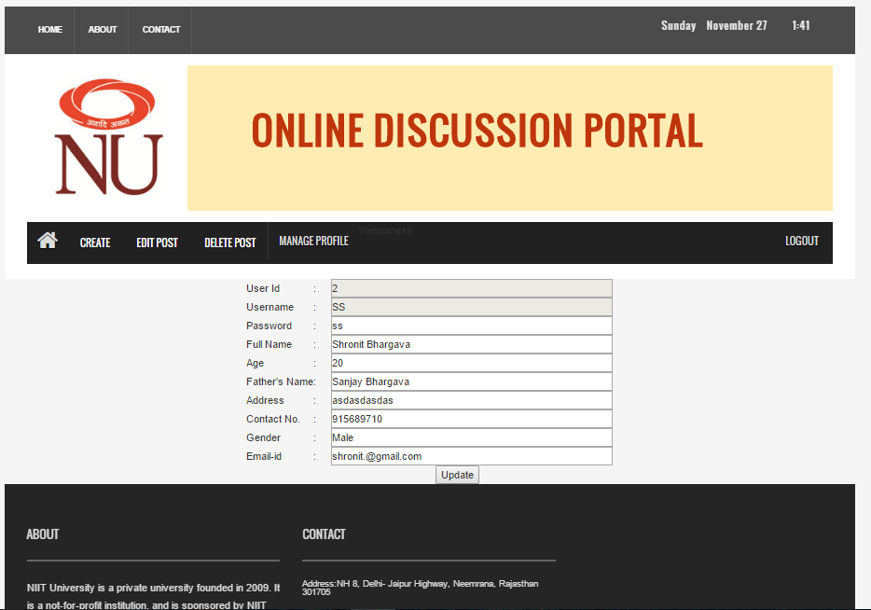

Actual Output: The changes were updated

**Logout**

Input:Click the logout button

Desired Output:The Web should get reverted back to the login page

Actual Output: Gets redirect to the login page

**Approve Post(Approving lost,found and event post)**

Input: Select the post to approve and click approve hence the post appears in the post on news feed

Desired Output:The post gets approved and updated in the database

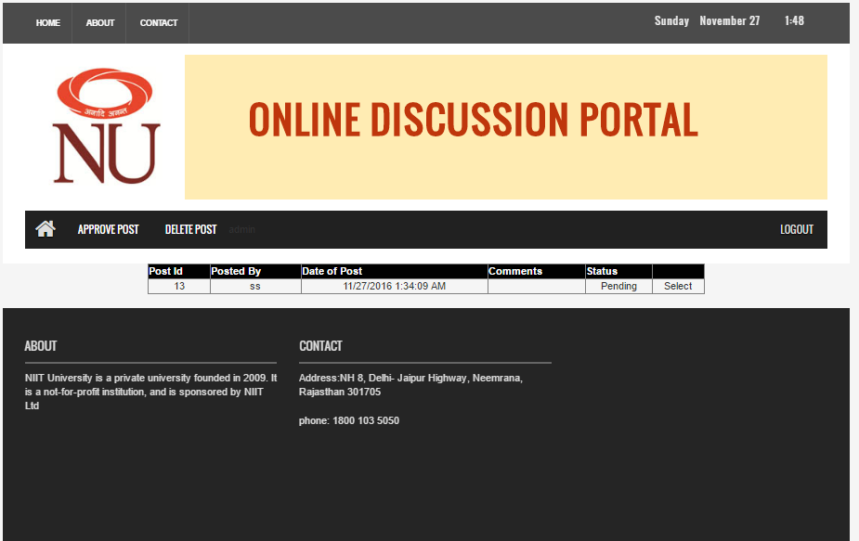

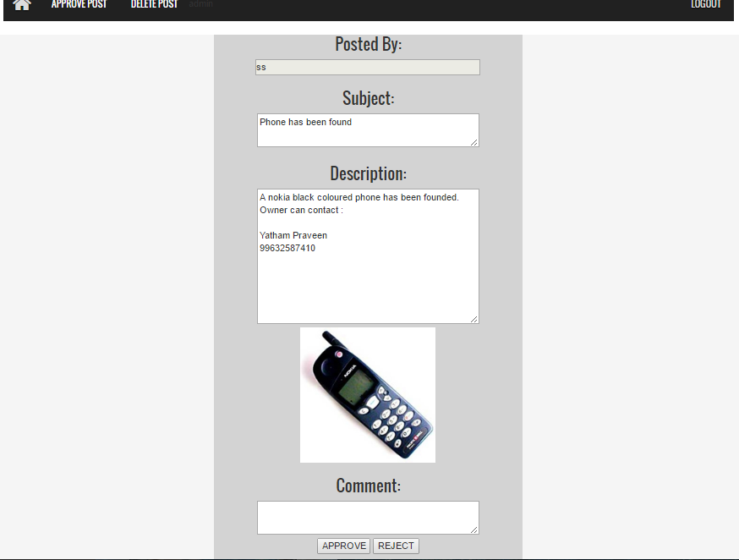



Actual Output: The post gets updated in database and appears in news feed

**Add User**

**Positive Scenario**

Input: Select the Add user button and enter all the details(mandatory) and also the not specifically required ones that appear and click add user

Desired Output: a new user is created and details are added to the database

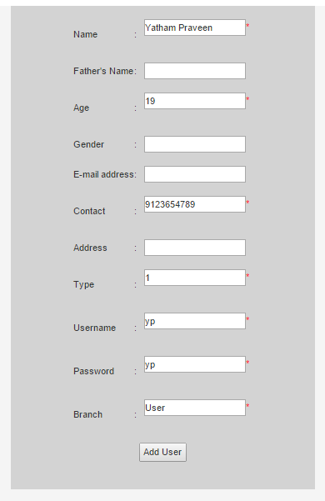

Actual Output: A new user was created and the database is updated with details

**Negative Scenario**

Input: Not entering the mandatory fields

Desired Output: A new user should not be created

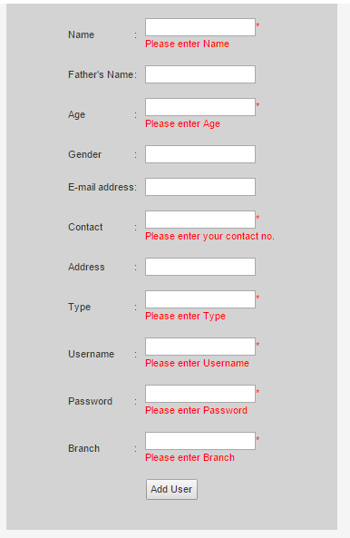

Actual Output: New User is not created

**Edit Profile**

Input: Select the user whose data the admin wants to change and enter the new entries and click edit

Desired Output: New entries are updated in the database

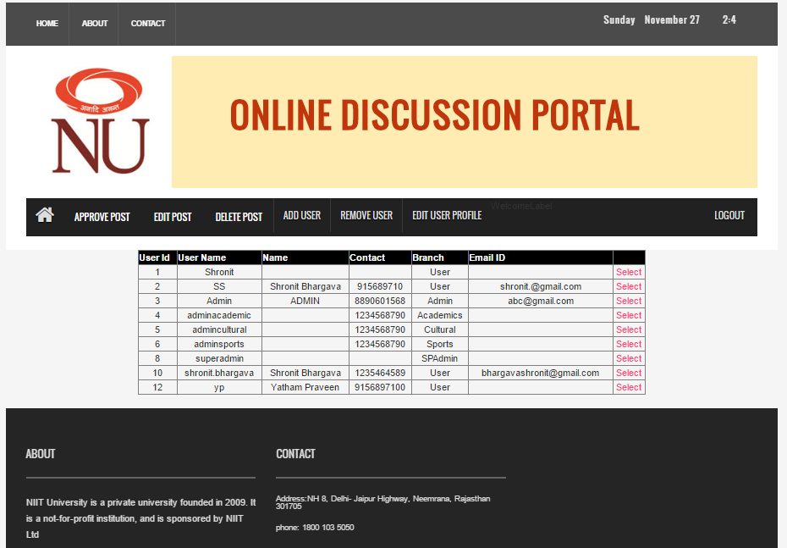

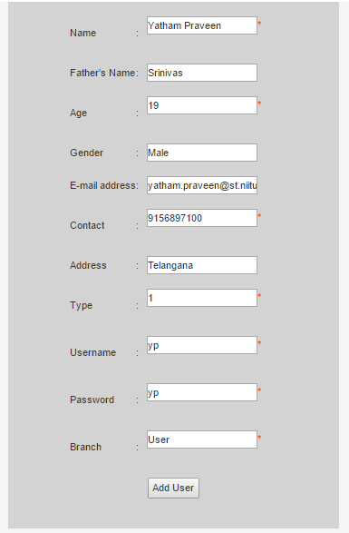

Actual Output: New entries were updated

**Remove User:**

Input:Select Remove User button and then select the user to delete

Desired Output:The selected user should get deleted from the user

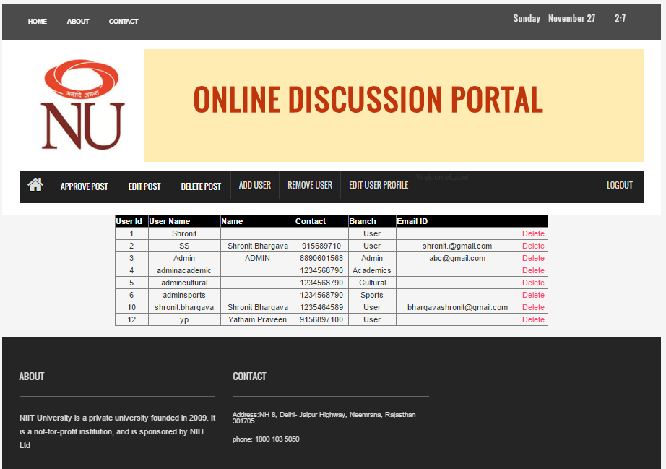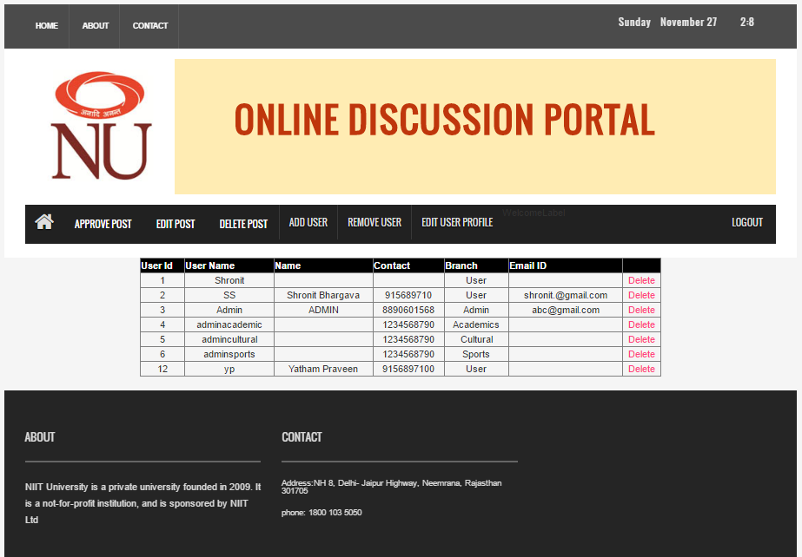

Actual Output:The User gets deleted from the database